(Approx. 854 words)

My Life with Devices
By Nancy DeMarte, 1st VP, Sarasota PCUG, Florida
December 2013 Issue, PC Monitor
www.spcug.org
ndemarte (at) Verizon.net

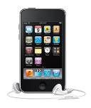
It all started about six or seven years ago with my first device, an iPod Touch. This cell phone-sized device does not make phone calls, but does nearly everything else. It introduced me to the seemingly limitless i-Tunes store and helped me navigate through the maze of managing my music and “apps.” This little device made me realize that I could carry hundreds of photos and songs in my purse, as well as get access to the Internet and my email in any Wi-Fi hotspot. I walked the treadmill at the gym to the rhythm of my workout playlists and showed photos of my grandchildren to everyone who would look.

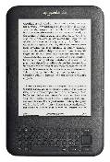
My second device was an original Kindle, an electronic book reader. As both a reader and a traveler, I was looking for a way of transporting the several books I’d need for one of our long cruises. Amazon’s Kindle was nothing fancy, but was exactly what I wanted. It too was a Wi-Fi only device, although the Internet was only needed for downloading books. Even now before a trip, I search for and download a number of books from the Kindle Store at Amazon, most free or very low cost. Then I turn off the Wi-Fi to save battery power and read away. When I fall asleep at night while reading in bed, Kindle also goes to sleep in a few minutes, saving my place in the book.

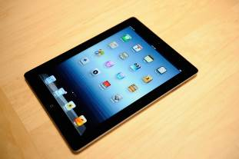
When the iPad first appeared on the market in 2010, I bragged to friends that I didn’t need anything that big when I could do it all on my iPod Touch. But being the techno fan that I am, I couldn’t resist jumping in when iPad 3 came out in 2012. It’s amazing how much easier it is to read email or play Words with Friends on that larger screen. Over time I got smarter about apps: fewer games and more utilities. When the Florida thunderclouds appear overhead, I check the time lapse radar with my RadarCast app. I keep in touch with my son and daughter with FaceTime or Skype. Although I still use my Kindle for reading books, I enjoy magazines on the iPad because they’re in color and never get recycled. Email is easier on the iPad, too, both reading and writing. When my husband and I do the morning NYT crosswords each day, the iPad is our quickest cheating option. I have a portable stock of favorite recipes in the Recipe Book app and regularly download new ones from many of the best-known websites.

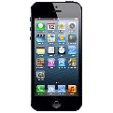
I was a late adopter of cell phones, and even then I chose a cheap, basic phone. My mother was in her 90’s; I needed to be on call. About then, a friend gave me very good advice: “Have no more than one device that has a monthly fee.” The cellphone became that device. It was only this year that I recycled the basic phone in favor of an iPhone 5. And it has turned out to be the right move. Last summer we rented a cottage on a lake where there was no Wi-Fi. I found that my iPad lost about 75% of its use to me because I had no Internet access. But my iPhone could do it all – read/send email, search the Net, play music, locate restaurants, talk to me, and take better pictures than my camera. You get the idea. A smartphone makes traveling a lot easier.

You may have noticed that I haven’t mentioned computers among my devices. I have both a desktop and laptop and find them invaluable. When I need to write an article or set up a budget or make a greeting card or create a presentation -- in other words, when I need to produce something – nothing beats my computers. The iPad offers several word-processing apps, even a small version of Word, but I like the full power of Microsoft Office, Photoshop Elements, and other full-featured productivity applications which work best on a PC, say nothing of the large monitor and classic keyboard. I use my “little” devices, as my husband calls them, for enjoying media and gathering information.

Besides the cost, there are challenges to owning all these devices: three cords for recharging, three cases, syncing, updating, and carrying them through security at airports. But I have a feeling that we are right now in a short transitional period. I have no doubt that within the next decade or two we will be able to do it all on a device that’s no bigger than a ball point pen that can project a keyboard on the table and a monitor on the wall, all in response to our verbal commands. It will let us produce, entertain us, and keep us in touch with friends and family. All our personal devices will be packed into one. For now, though, like many other people, I’m dealing with a device management challenge that I really don’t mind at all.

